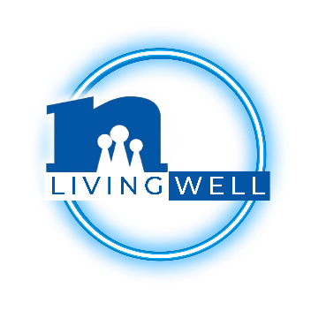
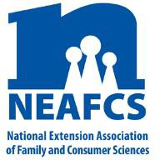
Insert your Extension logo here

[Insert date]
[Insert location]
Contact: [Insert contact name, phone, and email]

Extension Living Well Month Proclamation

WHEREAS, the health and well-being of the family are crucial to the functioning of the Nation and to providing adults and youth with the necessary skills and knowledge to help them achieve the best quality of life possible; and

WHEREAS, physically, psychologically, socially, and emotionally strong families provide strength for future generations; and

WHEREAS, Extension is a nationwide educational network through the land-grant universities, funded cooperatively through the U.S. Department of Agriculture, State governments, and County governments; and

WHEREAS, [UNIVERSITY] Extension [COUNTY] initiatives in nutrition, healthy lifestyles, food safety, financial management, parenting, and environmental health enable citizens to gain knowledge and skills to lead full and productive lives; and

WHEREAS, Extension offers educational workshops, seminars, publications, and websites to help families and individuals, farms businesses, and communities; and

WHEREAS, the designation of “Extension Living Well Month” is a fitting tribute to the National Extension Association of Family and Consumer Sciences professionals and local staff who provide education that is critical to the quality of life of adults, youth, and families.

NOW, THEREFORE, I, [PUBLIC OFFICIAL’S NAME], [TITLE OF PUBLIC OFFICIAL] of [LOCATION], do hereby proclaim the month of March [YEAR] as

“EXTENSION LIVING WELL MONTH”

in [LOCATION], and I encourage our residents to take advantage of the educational opportunities that Family and Consumer Sciences educators of [UNIVERSITY] Extension offer in the community.

In testimony whereof, I have hereunto set my hand and caused to be affixed the Seal of [LOCATION], this [X] day of [MONTH], [YEAR].
[PUBLIC OFFICIAL’S NAME],
[TITLE OF PUBLIC OFFICIAL]
Witness: [TITLE], [NAME]

Extension staff:
If you have not worked on getting an official to sign a proclamation, you may want to ask a co-worker or county director for assistance to work through this process. Start early in case it takes a while to go through the steps to get the proclamation signed. Be ready to have a photo taken for the local media if the newspapers in your area cover this news. In some towns, getting a proclamation is a quick and easy process and in other cities may take more time. The Extension Living Well Month proclamation could be issued on fancy paper.

Be sure to edit the proclamation to include your own University name and location.

